Children will focus on consolidating their letter formation.

Children need to be made aware of:

• Where the letter starts and finishes.

• Where the individual letter stands in regard to the baseline.

• Ascenders and descenders.

• Spacing and finger space between words.

• Consistent writing size.

• Capital letters and their appropriate use.

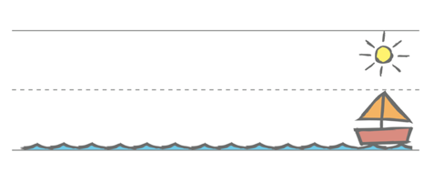Teachers will adapt the lesson and weekly focus for Year 2 children whose handwriting is more secure.

Children will have handwriting modelled to them using the RWI template.

|  |  |
| --- | --- |
| **KS1** | |
| Term 1 | Stage 1a: focusing just on letter formation  1- around letters  **c a o**  2- around letters **d g q**  3- down letters  **l t b**  4- down letters  **p k h**  5- down letters  **i j m n**  6- down letters **r u y**  7- Curly letters **e f s**  8- ‘ Zigzag’ letters: **v w z x**  9- Capitals for around letters  10- capitals for down letters  End of term check |
| Term 2 | 1- capitals for down letters  2-capitals for zigzag letters  3- consolidation of capitals  Moving on to Stage 1b focusing on where letters sit:  4- sun letters b d  5- sun letters hkl  6- boat letters  **a c e i m n**  7- boat letters  **o r s**  8- boat letters  **u v w x z**  9- Water letters **g j p q y.**  10- ‘Water letters’: g j p q y.  End of term check |
| Term 3 | 1- practising all the capital letters  2- practising all the capital letters  3- practising the numbers 0-9  4- practising numbers 10-20  5- double letters **ffs s ll tt**  6- mixing all the letter families  7- practising ch unjoined  8- practising wh unjoined  9- practising st unjoined  10- practising ck qu unjoined  End of term consolidation |